
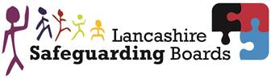
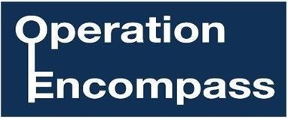
Draft letter to parents
This is an example of a letter to inform parents and carers about Operation Encompass

Dear Parent/Carer,

This letter is to inform you / remind you that our school is participating in Operation Encompass.

Operation Encompass is a unique Police and Education early intervention safeguarding partnership which ensures that a child's school is informed, prior to the start of the next school day, that there has been an incident of Domestic Abuse to which the child or young person has been exposed, and which might then have an impact on them in school the following day.

Each school is informed of all Domestic Abuse incidents, not just those where an offence can be identified or those which are graded as high risk. The partnership recognises that all incidents of Domestic Abuse can be harmful to children and young people.

This information will be shared throughout the year, including school holidays and the weekends. Information will only be shared with the school by the police where it is identified that a young person was present, witnessed or was involved in a domestic abuse incident.

A nominated member of staff, known as a Key Adult, has been trained to liaise with the police. At insert school name our Key Adult is insert details. They will be able to use information that has been shared with them, in confidence, to ensure that the school makes provision for possible difficulties experienced by children or their families. The Key Adults will keep this information confidential, and will only share it on a need to know basis, for instance, to teaching staff for the child or young person. It will not be shared with other school students.

Operation Encompass was first introduced in Plymouth in February 2011, and has proved very effective in providing appropriate and timely support to young people affected by domestic abuse. This initiative has been implemented across the whole of the Lancashire Police area. If you would like some more information about it, you can view it online at www.operationencompass.org.

We are keen to offer the best support possible for our pupils and a recent review of Operation Encompass showed that it is beneficial and supportive for all those involved.

Yours sincerely,

Chair of Governors Head Teacher

